**Oakland University**

**School of Electrical & Computer Engineering**

**Winter 2023**

**ECE 4721/5721**

**Embedded System Design**

**Lab #4**

Jacob Dunn

4 April 2023

**Part 1, Thermistor**

This experiment was to output a temperature value on a seven-segment display using the KL25Z by reading a value from a thermistor and converting that number to a temperature with an equation calculated using figure 7 in the appendix. The decimal point was always included after the second digit to indicate a two-digit whole number output. This required the KL25Z, a seven-segment display, a thermistor, a 5kΩ resistor and lots of wires to connect the required components. The tens digit seven-segment display was connected on port E to pins 2, 4, 5, 20, 21, 22, 23, and 29, and the ones digit seven-segment display was connected on port C pins 11, 5, 3, 7, 6, 10, 4, and 0. The thermistor was connected on port C pin 9. The thermistor acts as an ADC and therefore does not automatically output the temperature value but requires some conversion to get this value. The values were determined using the given appendix in the lab handout and included at the end of this document in figure 7. My calculated values are given below in figure 3 and are included in the source code provided in the zip file under the Part1 folder and the video demo is available in the main lab4 folder entitled Part1_Demo. This demo shows the output with the provided code and a fluctuation between a reading of 24°C and 25°C. Figure 1 below contains the breadboard used for the experiment and figure 2 shows the flow diagram for the code.

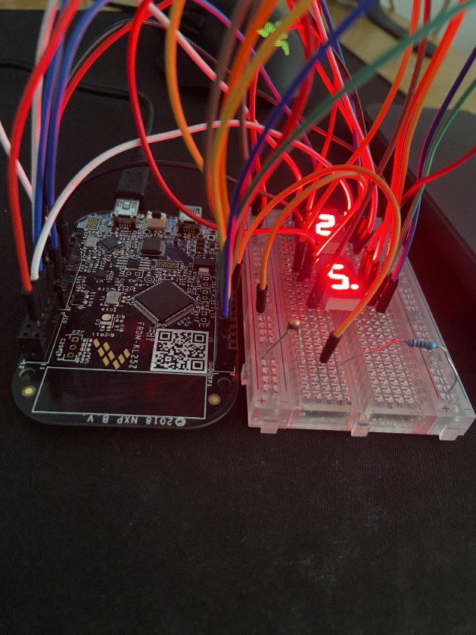

Figure 1. Temperature Sensor Breadboard Layout

Figure 2. Flow Diagram



Figure 3. Temperature Conversion

**Part 2, Proximity Sensor**

The purpose of this experiment was to light an LED based on the detected distance of a detected object. This utilized the KL25Z, an IR emitter, an IR phototransistor, a RGB LED, a 10kΩ resistor, a 5kΩ resistor, and three 220Ω resistors. These components were connected to the 5V source, where the active low IR emitter was connected to PE21, the active low RGB LEDs were connected to PE29, PE23, PE22, and the active high IR phototransistor was connected to PE30. This circuit was to function the same as a proximity detector in the automotive industry would, however I could not get my RGB LEDs to light up, and I do not know if this was because they were burnt out or if there was an issue in the configuration. Despite this defect, I continued with the rest of the lab and implemented the proximity detection functionality regardless of the lack of LED output. Most of the code was based off the code provided in the section of the textbook entitled “Infrared Proximity Sensor”. Figure 4 shows the breadboard layout and figure 5 shows the flow diagram for this part. The source code is provided in the zip file under the Part2 folder and there is no video demo for this part.

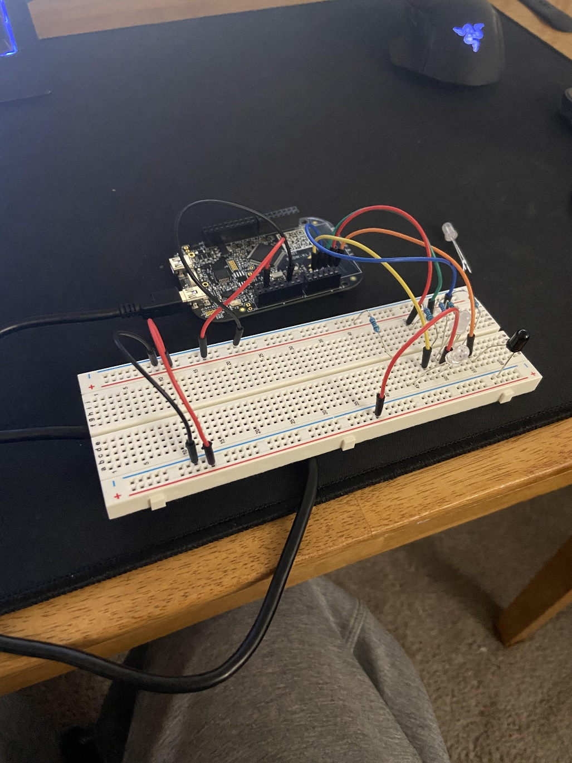

Figure 4. IR Breadboard Layout

Figure 5. Flow Diagram

**Appendix**

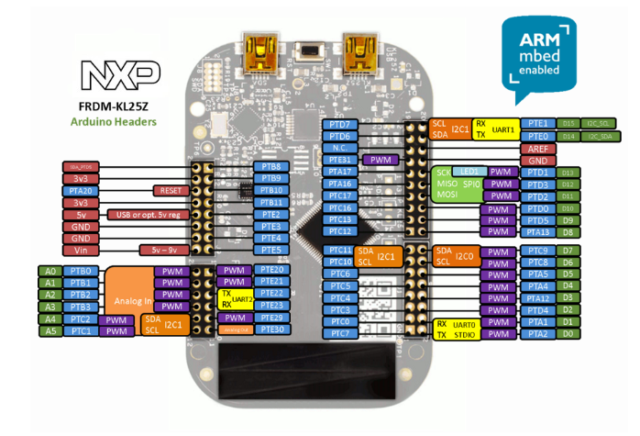

Figure 6. KL25Z Pinout

**Figure 7. Calculating Resistor Value information:**

